APS is opening the Summer Undergraduate Research Fellowship applications and the review process with the intent of the program moving forward as planned. However, the Society reserves the right to cancel the program at any time. Thank you for your understanding.
_______________________________________________________________
Online application deadline is February 1.
Late or incomplete applications will not be reviewed.
READ ME FIRST! You will use the American Physiological Society’s (APS) online Awards Application System to submit your application. All files uploaded to the application must be PDF files (PDF version 1.5 or above). You can convert documents to PDF format online here: https://createpdf.adobe.com/

Step 1: Determine Your Program Eligibility

1. Read through the eligibility requirements for the following program to determine if
you are eligible to apply:

Summer Undergraduate Research Fellowship (SURF)

- Undergraduate Year: 1st -year through 3rd -year undergraduate student enrolled full time
- GPA: Students must have an over-all GPA of ≥3.0 to apply (0-4.0 scale)
- Research Experience: No more than nine (9) calendar months of research experience in a physiology laboratory
- APS Membership: Not required.
- Research Host: Must be an APS member in good standing.
- Citizenship: There is no citizenship requirement
- Website: https://www.physiology.org/UGSRF (see Eligibility Criteria)

Step 2: What you need BEFORE applying online

1. Find an APS member to serve as your research host and decide on a project.
a. The applicant needs to locate and contact an APS member in good standing to serve as a research host. You may need to contact your science department to inquire if anyone is a member or if they know anyone who is a member and has a working lab. If they are not an APS member, they will need to apply for membership. See Host Instructions.

2. Write a description of your research project.
a. Your research project description should be no longer than 500 words, be written by you, and the document must be submitted as a PDF file.
b. You must write this description. Do NOT ask your research host to do this for you. DO NOT COPY what your research host has given you. If the research plan is not written in YOUR OWN WORDS, it will not be reviewed by the Committee.
c. Research descriptions that are longer than 500 words will disqualify your application and it will not be reviewed.

3. Obtain a copy of your transcripts.
a. Upload your transcripts to your application.
b. Unofficial transcripts are acceptable. If the transcript is not in English, please provide an English translation of courses, grades, and grading system.

4. Write a one-page personal statement describing the following:
a. Your background, achievements, interests, and short-term goals.
b. Your long-term career goals.
c. How the research experience will positively influence your career development.
d. A statement concerning your choice of this particular of the APS member researcher who will host you in their lab.

5. Request two letters of recommendation.
a. One letter must be from the research host that you propose working with over the summer and the second from another a faculty member at your home institution. You will enter their email addresses in the application under “Recommendation Letter-Confidential” to have the system request them to upload the letter. If the faculty members do not receive an email with a link to upload the letter, please contact the program staff.

- Please provide this information to those writing the letters: To the extent possible, these letters should rank you, the applicant, in comparison to other students at similar levels. Both letters should speak directly to the issue of your potential to pursue a career in physiology as a basic research scientist. The letter from the research host should describe the basis or factors that resulted in an invitation to work in their laboratory. Letters should also comment specifically on your career aspirations and the stage of development of those aspirations.

6. Be prepared to answer the following:
a. Year Entered College
b. Undergraduate Major
c. Over-all Grade Point Average (GPA)-to date on a 4.0 scale
d. Science/Math GPA
e. College Awards or Honors
f. Host Scientist’s APS Member ID Number
g. Host Scientist’s Full Name
h. Host Scientist's Institution
i. Host Scientist’s Department
j. Host Scientist’s Address
k. Host Scientist’s City
l. Host Scientist’s State
m. Host Scientist’s Zip Code
n. Host Scientist’s Email Address
o. Host Scientist's Phone Number
p. Have you worked less than nine (9) months in a research lab at the time of application?
q. Describe previous or current research involvement (include length of time) with this researcher.
r. Describe any work you have done in any other research labs as an undergraduate
s. Working Title of Research Project
t. Research Project Hypothesis
u. How does this project relate to your long-term career goals?
v. Have you applied for any other fellowships?
w. If yes, how would you handle it if you received both fellowships?
x. If you have a disability, describe the disability and any specific lab accommodations you require.
y. How did you hear about this fellowship opportunity?

STEP 3: Apply on the APS Online Awards Application System

A. Logging on for the FIRST TIME and creating an APS Awards site profile.

- Go to: https://awards.physiology.org/

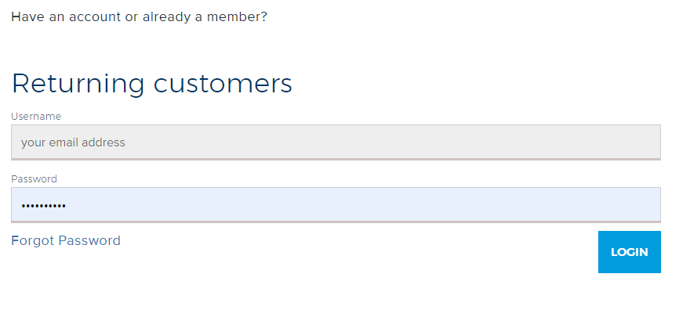

2. Create a profile with your unique email address and a password. Select “login.” Record your password for future use.

3. Complete your profile.

4. Do not close this window. Scroll down to the bottom and click the “Submit” button.
You will be automatically redirected to the Applicant dashboard which contains a list of the awards that you are eligible for.

5. Scroll down until you see the Summer Undergraduate Research Fellowship application and click “Apply” button to proceed.

6. Once you click the apply button you will be directed to the disclosure statement. Answer the disclosure statement question and the questions for the SURF application will appear.

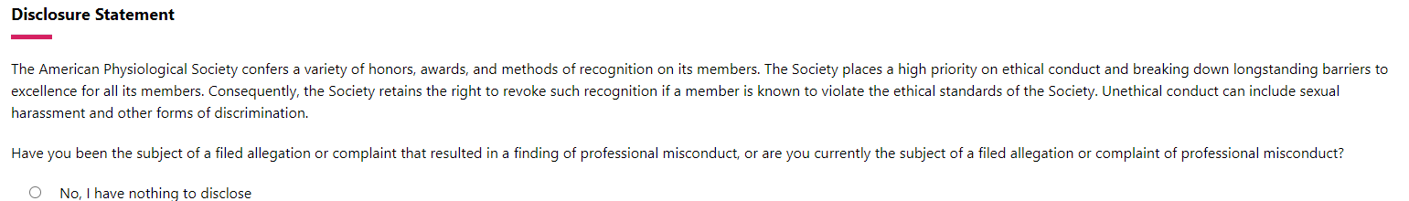

- You can now begin submitting your application information.

- Submit your application now or later. When you are done, you have two options to select at the bottom of the online form:

a. Save & Continue: This option saves your entries, and you can return to this saved session if you are unable to complete your application.


b. If you have uploaded all your files and answered all the questions the “submit application button will appear and the bottom of the application. Click on the “submit application” button to save your application. This option saves your entries and notifies the APS Office and Application Review Committee that your application package is ready for consideration into the program. However, if necessary, applicants can still edit their application until the February 1st deadline.

c. Withdraw Application: If you do not wish to apply for this award, please click the “Withdraw Application” button to completely delete your application.

B. Returning to a saved session

1. Login with your email and password at: https://awards.physiology.org/

2. If you’ve already started an application, you should see it listed on the main Award page once you’ve logged in. Select the award name from the list of awards and click “Continue” to continue completing your application.

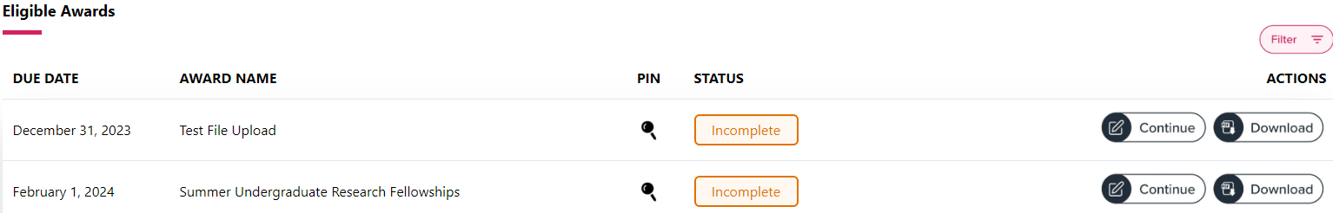

3. Refer to Step 3, #8 for instructions on saving or submitting your application.

For additional questions, please contact one or more of the following individuals:
If you have any questions or concerns, please contact one of the following staff members.

      - Kristine Ogary, Learning & Career Specialist kogary@physiology.org

      - Margaret Stieben, Director, Careers & Professional Development
mstieben@physiology.org

      - Scarletta Whitsett, Manager, Awards
swhitsett@physiology.org

